
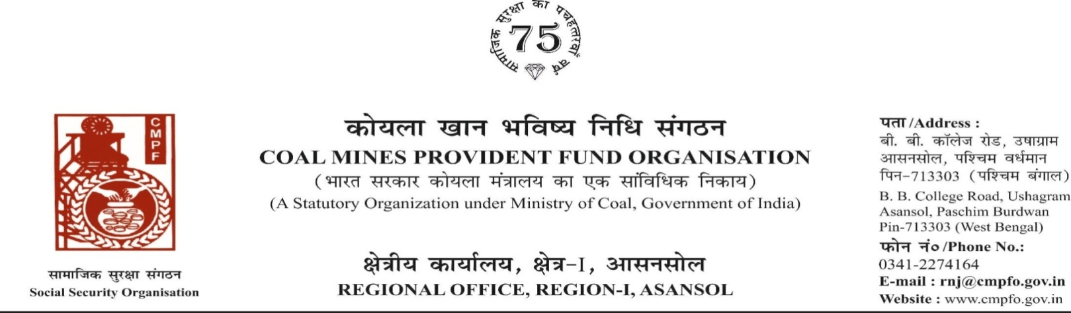
CPF/118/Misc/Ext-out/R-I/ASN/ Dated-10/07/2025

To,
The Regional Commissioner
Coal Mines Provident Fund ,
R.O- Talcher
AT:- Jagannath colony
P.O & P.S:- South Balanda
Dist:- Angul , State:- Odisha
Pin:- 759116

Sub- Supply of Extract of "VV" statement

Ref:-CPF/155/Extract incoming/TLHR-25/Misc/Tal/447

Sir,

On the subject and reference cited above,enclosed please find herewith the extract in r/o-
Sri Mahamood Miya CMPF A/C No- NGP/19/2724 as required. Ledger Card is not available in this region.

Encl- As above

Yours faithfully

Assistant Commissioner

